1. What is Maven

Maven is a powerful project management tool that is based on POM (project object model). It is used for projects build, dependency and documentation.

It simplifies the build process like ANT. But it is too much advanced than ANT.

1. Understanding the problem without Maven

There are many problems that we face during the project development. They are discussed below:

**1) Adding set of Jars in each project:** In case of struts, spring, hibernate frameworks, we need to add set of jar files in each project. It must include all the dependencies of jars also.

**2) Creating the right project structure:** We must create the right project structure in servlet, struts etc, otherwise it will not be executed.

**3) Building and Deploying the project:** We must have to build and deploy the project so that it may work.

What it does?

Maven simplifies the above mentioned problems. It does mainly following tasks.

1. It makes a project easy to build
2. It provides uniform build process (maven project can be shared by all the maven projects)
3. It provides project information (log document, cross referenced sources, mailing list, dependency list, unit test reports etc.)
4. It is easy to migrate for new features of Maven

What is Build Tool

A build tool takes care of everything for building a process. It does following:

* Generates source code (if auto-generated code is used)
* Generates documentation from source code
* Compiles source code
* Packages compiled code into JAR of ZIP file

# **Maven pom.xml file**

**POM** is an acronym for **Project Object Model**. The pom.xml file contains information of project and configuration information for the maven to build the project such as dependencies, build directory, source directory, test source directory, plugin, goals etc.

Maven reads the pom.xml file, then executes the goal.

Before maven 2, it was named as project.xml file. But, since maven 2 (also in maven 3), it is renamed as pom.xml.

## Elements of maven pom.xml file

For creating the simple pom.xml file, you need to have following elements:

* Installs the packaged code in local repository, server repository, or central repository

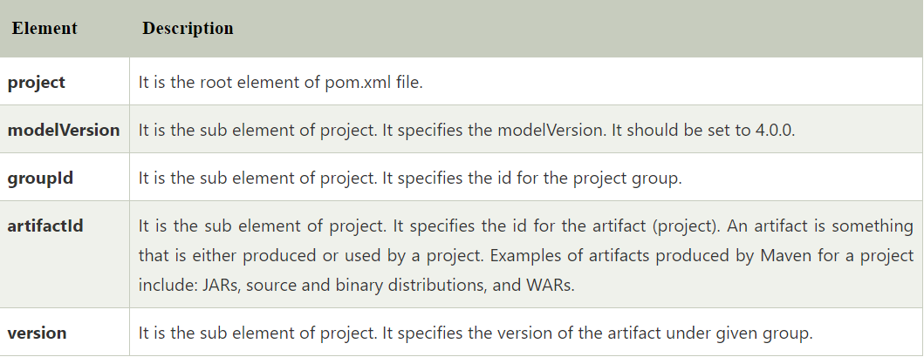

## Maven pom.xml file with additional elements

Here, we are going to add other elements in pom.xml file such as:

